How to terminate cat5e cable for an Ethernet Radio
Equipment Needed:

RJ-45 Crimper RJ-45 End Outdoor Shielded Cat5e Cable Cable Cutters
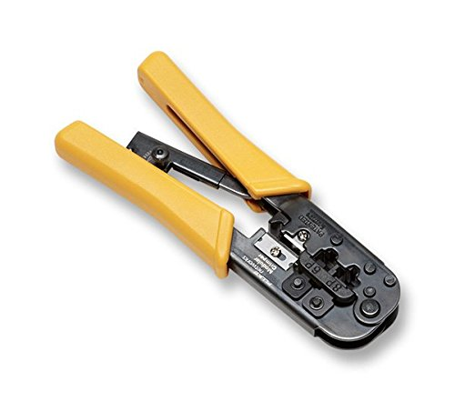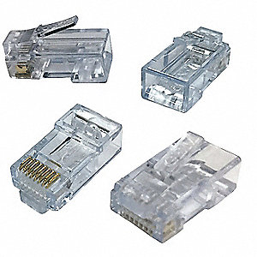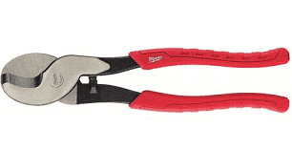

At the radio end, take the cable cutters and score the outer jacket 12” from the end of the cable. Bend the cable at the score causing the jacket to break free and remove the outer jacket. For the cabinet end, follow the same procedure, but remove 36” of the outer jacket.
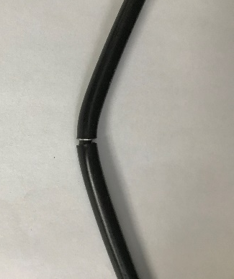
For both ends, use the strippers on the RJ-45 Crimper to score and remove the inner jacket 3” from the end of the cable.

Expose the colored conductors, remove an access gel (if present), and untwist them. Once they are untwisted down to the jacket, untwist each pair 2-3 more times so they are easier to re-order.
Re-order the conductors to follow the T-568B standard shown below.
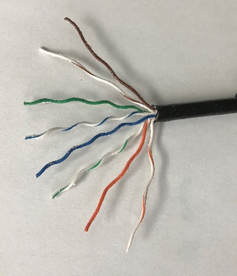
Hand work the conductors until they are in the correct order and lying flat.
Use any cutting tool to cut the conductors 0.5” from the jacket.
With the clip facing away, place the RJ-45 end on. The end of the inner jacket should slide into the base of the RJ-45 end and the conductors should slide all the way up into their individual channels.
If this is not the case, start the end over until this is achieved.
Conductors up in channels
Inner Jacket inside RJ-45 end
Use the RJ-45 crimper to crimp down the RJ-45 end to the cat5e cabling. The base of the RJ-45 end will pinch down on the inner jacket allowing it to carry any tension at the connection. Also, the crimp may have over compressed the tab on the RJ-45 end. Gently bend it back in place.
RJ-45 tab gently pulled back out
Inner Jacket pinched by RJ-45 end
Before connecting the cable to the radio, create a drip loop as shown below. The cable shall be ran through the riser if possible and only the inner jacket shall be used for the drip loop. This prevents water from getting in between the inner and outer jacket and down to the POE injector.
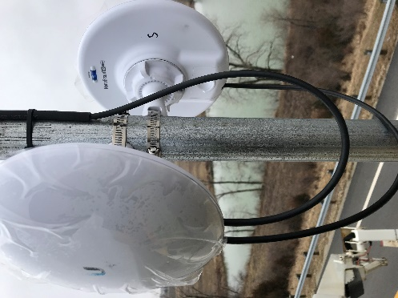
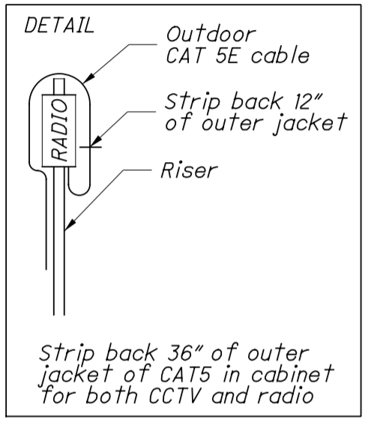
Outer Jacket
Inner Jacket
Inner Jacket Drip Loops
Example of a Bad RJ-45 Termination
